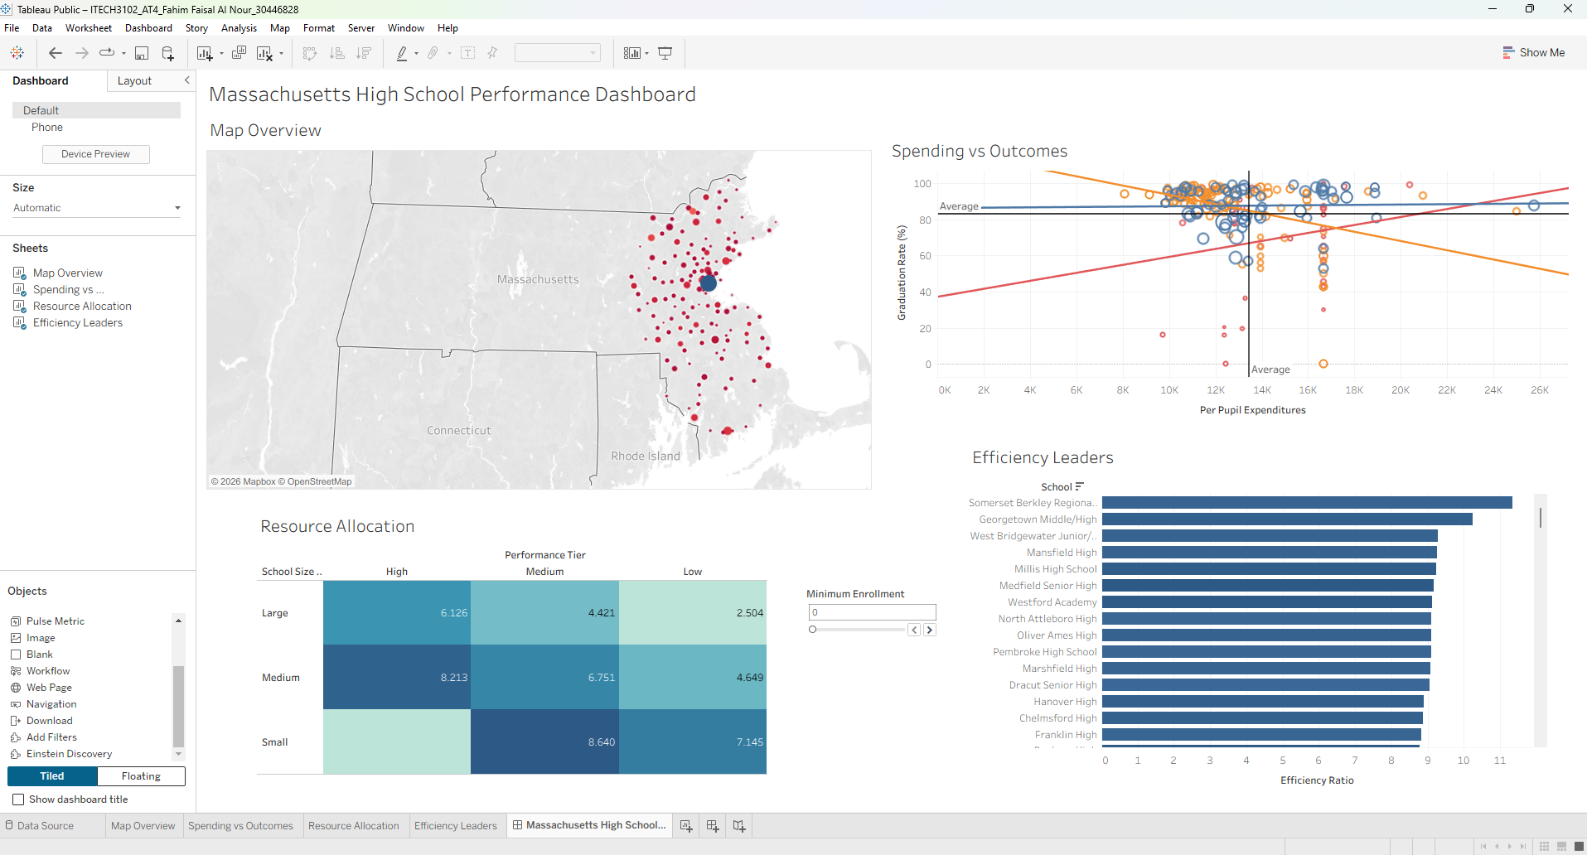  Assessment Task 4: Capstone Project  Assessment: Task 4 - Interactive Dashboard Design Plan (Proposal) | Abstract  This document presents my design plan for an interactive dashboard that explores Massachusetts high school performance data. I have selected the school information dataset because it contains rich variables that support meaningful analysis of educational equity. This plan describes my dataset selection, data transformation approach, user scenarios, analytical questions, and proposed visualization implementation.  ClientX  Course: ITECH3102: Big Data and Data Visualisation

Student ID: StudentIDX
Institution: Federation University Australia
Submission Date: 18 October 2026

1. Dataset Selection and Overview
I have selected the dataset assessment task 4-data-1-school-info.csv. This dataset records institutional, financial, and academic performance attributes across Massachusetts public and charter high schools, comprising 18 attributes across more than 220 school records. The raw attributes span four primary domains:
- Geographic and Nominal Identifiers: State, City, District, and School (categorical/nominal and spatial fields).
- Institutional Scale and Staffing: Enrollment (discrete quantitative) and Student-Teacher Ratio (continuous quantitative).
- Financial Investment: Per Pupil Expenditures (continuous quantitative, measured in US dollars).
- Co-Curricular and Academic Outcomes: Number of AP classes (Nbr AP classes), Number of Varsity Sports (Nbr Varsity Sports), and Number of Clubs (Nbr Clubs) as discrete quantitative counts, alongside Graduation Rate (%), Percentage to College (Perc to College), 10th Grade MCAS scores (English, Math, Science), Average SAT scores (Reading, Writing, Math), and Percentage Scoring AP Proficiency (continuous quantitative rates and scores).
I selected this dataset over the order-information dataset because it supports a high-impact public policy narrative regarding educational equity. Combining municipal geography with school funding and standardized test outcomes enables multi-dimensional visual exploration for policymakers, district administrators, and education researchers.
2. Data Analysis and Abstraction
Initial data profiling indicates that several attributes contain missing values (nulls), particularly Per Pupil Expenditures, MCAS Science, SAT scores, and AP Proficiency among charter, vocational, and alternative schools. Rather than imputing synthetic averages that would distort real-world variance, I will manage missing records using explicit Tableau filter configurations and hide default warning indicators so the visual interface remains clean while preserving data integrity.
Following Munzner's (2014) data abstraction framework, I will engineer six derived fields, bins, and parameter controls in Tableau to uncover patterns that raw attributes cannot show on their own:
1. Resource Index (Quantitative Calculated Field): Normalizes co-curricular and advanced academic offerings per 100 students using the formula:
Resource Index = ([Nbr AP classes] + [Nbr Varsity Sports] + [Nbr Clubs]) / [Enrollment] * 100
2. Resource Index (bin) (Ordinal Bin Transformation): Groups continuous Resource Index values (ranging from 0.00 to 21.23 across 191 distinct values) using a bin size of 1 (0 to 21) to evaluate how incremental resource availability relates to college attendance.
3. Outcome Score (Quantitative Calculated Field): Computes a composite academic achievement metric across four core outcome indicators using the formula:
Outcome Score = ([Graduation Rate (%)] + [Perc to College] + [10th Grade MCAS English] + [10th Grade MCAS Math]) / 4
4. Efficiency Ratio (Quantitative Calculated Field): Measures composite academic outcomes achieved per $1,000 of per-pupil spending to highlight fiscally efficient schools using the formula:
Efficiency Ratio = [Outcome Score] / ([Per Pupil Expenditures] / 1000)
5. School Size Category and Performance Tier (Categorical/Ordinal Groupings): School Size segments institutions by Enrollment into Small (<500 students), Medium (500 to 1,200 students), and Large (>1,200 students), while Performance Tier classifies schools into ordered High, Medium, and Low tiers.
6. Minimum Enrollment (Interactive Parameter Control): Configured as an Integer parameter with a range from 0 to 5,000, a step size of 100, and a default value of 1,000, enabling users to dynamically filter out smaller schools across the dashboard.
3. Scenario Description
The primary target audience for this dashboard consists of Massachusetts state education policymakers and district administrators responsible for resource allocation and school improvement grants, while parents and researchers represent a secondary audience.
In visualization design, a task is design-independent (what analytical goal the user wants to accomplish), whereas a scenario is design-specific (how the user interacts step-by-step with a particular visual interface). Consider Maria, a state education policy analyst investigating regional performance gaps. Following Shneiderman's (1996) visual information-seeking mantra ("overview first, zoom and filter, then details-on-demand"), Maria opens the dashboard and scans the geographic map to observe statewide SAT and MCAS patterns. Noticing a cluster of lower-performing red markers along the southeastern coast (such as the New Bedford area), she clicks directly on that cluster. Cross-worksheet filter actions automatically update the scatter plot, resource heat map, and efficiency ranking bar chart to isolate those coastal schools. Next, Maria adjusts the interactive Minimum Enrollment parameter slider to 1,000 to exclude small specialized schools and benchmark large comprehensive high schools against statewide efficiency leaders.
4. Questions and Tasks
Five multi-variable analytical questions drive the visual storytelling plan, avoiding simplistic single-statistic queries:
Question 1: Does higher per-pupil expenditure correlate with better graduation rates?
- Abstract Task: Compare quantitative correlation and variance across school size categories.
- Planned Visual and Rationale: A scatter plot mapping Per Pupil Expenditures (x-axis) against Graduation Rate (%) (y-axis), sized by Enrollment and colored by School Size with linear trend lines and statewide average reference lines.
- Answer Planning: Reveals whether higher spending guarantees higher graduation rates or if medium and large schools achieve strong outcomes at moderate expenditure levels ($10,000 to $16,000).
Question 2: How do MCAS performance and SAT scores vary geographically?
- Abstract Task: Discover spatial clusters and regional disparities across municipalities.
- Planned Visual and Rationale: A proportional symbol map using city latitude/longitude, encoding Enrollment by circle size and academic achievement via a diverging red-to-blue color scale.
- Answer Planning: Contrasts high-enrollment metropolitan hubs (Greater Boston) against lower-performing regional clusters in southeastern and central Massachusetts.
Question 3: How do school resources vary across different school sizes and performance tiers?
- Abstract Task: Compare derived resource intensity across two categorical/ordinal dimensions.
- Planned Visual and Rationale: A two-dimensional heat map crossing School Size (rows) with ordered Performance Tier (High, Medium, Low columns), using sequential teal-blue color saturation and text labels for average Resource Index.
- Answer Planning: Identifies whether large low-performing schools suffer from resource dilution compared to small and medium schools.

Question 4: How do school resources relate to college readiness?
- Abstract Task: Evaluate multivariate progression between resource availability and college attendance rates.
- Planned Visual and Rationale: Initially planned as a parallel coordinates plot, with a binned vertical bar chart of Resource Index (bin) (bins 0 to 21, step size 1) versus AVG(Perc to College) as a cleaner alternative if line occlusion occurs across 220+ schools.
- Answer Planning: Demonstrates whether higher per-student resource brackets consistently yield higher college attendance rates (90%+) while isolating vocational outliers.
Question 5: Which schools achieve high outcomes with lower expenditures?
- Abstract Task: Rank individual institutions by derived fiscal efficiency.
- Planned Visual and Rationale: A horizontal bar chart sorting School names in descending order by their calculated Efficiency Ratio.
- Answer Planning: Highlights top benchmark districts (such as Somerset Berkley Regional and Georgetown Middle/High) that deliver superior outcomes per dollar spent.

5. Proposed Implementation Approach and Dashboard Sketch
The interactive dashboard will be implemented in Tableau Public using a four-panel tiled grid layout designed according to Few's (2012) single-screen visibility principles and Munzner's (2014) channel effectiveness hierarchy:
- Panel 1 (Top-Left) - Map Overview: Proportional symbol map supporting geographic selection and spatial filtering.
- Panel 2 (Top-Right) - Spending vs Outcomes: Multi-channel scatter plot with reference lines and category trend lines.
- Panel 3 (Bottom-Left) - Resource Allocation: Ordered 3x3 heat map (High | Medium | Low vs. Large | Medium | Small), accompanied by an additional worksheet (Q4 College Readiness) for deep-dive reporting.
- Panel 4 (Bottom-Right) - Efficiency Leaders: Sorted horizontal bar chart ranking top schools by Efficiency Ratio, paired with the interactive Minimum Enrollment parameter slider (0 to 5,000, step size 100).
Proposed Dashboard Wireframe Sketch (2x2 Tiled Layout):
- Top-Left Panel (Map Overview): Proportional Symbol Map (City Lat/Long) | Color: Diverging Red-Blue (Performance) | Size: Enrollment | Interaction: Click mark to filter all dashboard panels.
- Top-Right Panel (Spending vs Outcomes): Scatter Plot (X: Per Pupil Expenditures, Y: Graduation Rate %) | Color: School Size (Blue/Orange/Red) | Size: Enrollment, with Trend and Statewide Average Reference Lines.
- Bottom-Left Panel (Resource Allocation): 2D Heat Map (Rows: Large, Medium, Small; Columns: Ordered High, Medium, Low Performance Tiers) | Color Saturation and Text Label: AVG(Resource Index).
- Bottom-Right Panel (Efficiency Leaders): Sorted Horizontal Bar Chart (Y: School, X: Efficiency Ratio) | Interactive Control: Minimum Enrollment Parameter Slider (Range 0 to 5,000, Step 100, Default 1,000).

6. Conclusion
This design plan establishes a rigorous, theory-driven blueprint for analyzing educational equity across Massachusetts high schools. By combining derived metrics, perceptual encoding principles, and synchronized Tableau filter and parameter actions, the proposed dashboard will empower policymakers to uncover actionable insights linking school funding, resource intensity, and student success.
References
- Few, S. (2012). Show Me the Numbers: Designing Tables and Graphs to Enlighten. Analytics Press.
- Munzner, T. (2014). Visualization Analysis and Design. CRC Press.
- Shneiderman, B. (1996). The Eyes Have It: A Task by Data Type Taxonomy for Information Visualizations. Proceedings of the IEEE Symposium on Visual Languages, 336-343.
- Tableau Software. (2024). Tableau Help Documentation. Retrieved from https://help.tableau.com

